Table des matières

KNN (100 words by code) : **Erreur ! Signet non défini.**

Fitting 3 folds for each of 3 candidates, totalling 9 fits **Erreur ! Signet non défini.**

train_r2_score = 0.8541603355011245 **Erreur ! Signet non défini.**

test_r2_score = 0.8466541056342308 **Erreur ! Signet non défini.**

KNN (100 words by code) 14

Fitting 3 folds for each of 1 candidates, totalling 3 fits **Erreur ! Signet non défini.**

train_r2_score = 0.8645383820579834 **Erreur ! Signet non défini.**

test_r2_score = 0.8550416337446058 **Erreur ! Signet non défini.**

RF (100 words by code): 31

Fitting 3 folds for each of 1 candidates, totalling 3 fits 31

train_r2_score = 0.8693095484106242 31

test_r2_score = 0.8640977329362426 31

RF (20 words by code) **Erreur ! Signet non défini.**

estimator RandomForestClassifier() **Erreur ! Signet non défini.**

params {'max_features': ['sqrt'], 'min_samples_split'... **Erreur ! Signet non défini.**

Fitting 3 folds for each of 4 candidates, totalling 12 fits **Erreur ! Signet non défini.**

train_r2_score = 0.7422506533762839 **Erreur ! Signet non défini.**

test_r2_score = 0.7427216920926275 **Erreur ! Signet non défini.**

KNN (20 words by code) **Erreur ! Signet non défini.**

estimator KNeighborsClassifier() **Erreur ! Signet non défini.**

params {'n_neighbors': [100, 200, 300, 500, 1000]} **Erreur ! Signet non défini.**

Fitting 3 folds for each of 5 candidates, totalling 15 fits **Erreur ! Signet non défini.**

train_r2_score = 0.7166170303288154 **Erreur ! Signet non défini.**

test_r2_score = 0.7161611864097733 **Erreur ! Signet non défini.**

KNN (150 words by code) 4

train_r2_score = 0.8638242265848174 4

test_r2_score = 0.8516379991490913 4

best_params: [{'n_neighbors': 10}] 4

KNN (150 words by code) 7

estimator KNeighborsClassifier() 7

params {'n_neighbors': [10]} 7

train_r2_score = 0.8857199294961405 7

test_r2_score = 0.8786847383455905 7

KNN (150 words code) avec scaling 10

estimator KNeighborsClassifier() 10

params {'n_neighbors': [10, 12, 30]} 10

**train_r2_score = 0.8887436941591199** 10

**test_r2_score = 0.88160213942746** 10

KNN (100 words by code) 13

train_r2_score = 0.8861802979450039 13

test_r2_score = 0.8843028732925106 13

best_params: [{'algorithm': 'auto', 'n_jobs': -1, 'n_neighbors': 10, 'weights': 'distance'}] 13

KNN (100 words by code) après une **PCA** (réduction de 37% des variables) 14

train_r2_score = 0.8066006199477299 15

test_r2_score = 0.8066613991369355 **Erreur ! Signet non défini.**

train_mse_result = 640934.347976053 **Erreur ! Signet non défini.**

test_mse_result = 688515.9724062481 **Erreur ! Signet non défini.**

best_params: [{'n_neighbors': 10}] **Erreur ! Signet non défini.**

KNN (300 word by code) 31

train_r2_score = 0.9067799185558865 35

test_r2_score = 0.9002613505135841 35

estimator KNeighborsClassifier() 35

params {'n_neighbors': [10]} 35

RBF (100 words by code) 26

train_r2_score = 0.8660274721935209 26

test_r2_score = 0.8619704613140461 26

best_params: [{'max_features': 'sqrt', 'min_samples_split': 10}] 26

SVC (100 words by code) 33

train_r2_score = 0.8660274721935209 33

test_r2_score = 0.8574120221236249 33

best_params: [{'C': 10, 'kernel': 'linear'}] 33

RFC - RandomForestClassifier (300 words by code) – the best 14

train_r2_score = 0.9220203002491947 19

test_r2_score = 0.9121740715978849 19

best_params: [{'max_features': 'sqrt', 'min_samples_split': 10}] 19

LREG (100 words by code) – 4min 23

best_params: [{'C': 30}] 23

train_r2_score = 0.8658603294232055 23

test_r2_score = 0.8622135780708685 23

LREG (300 words by code) 41

estimator LogisticRegression() 41

params {'C': [50]} 41

train_r2_score = 0.8932109645657327 41

test_r2_score = 0.8905974594298912 41

naïve MAYES (300 words by code) 38

estimator MultinomialNB() 38

params {'alpha': [1]} 38

train_r2_score = 0.9078283595696833 **Erreur ! Signet non défini.**

test_r2_score = 0.9073117364614356 **Erreur ! Signet non défini.**

mean_train_f1_score= 0.9392493667037067 38

mean_test_f1_score= 0.9379498799117439 38

# KNN (150 words by code)

## train_r2_score = 0.8638242265848174

## test_r2_score = 0.8516379991490913

## best_params: [{'n_neighbors': 10}]

estimator KNeighborsClassifier()

params {'n_neighbors': [10]}

df.shape : (82265, 4052)

X_train.shape - X_test.shape - len(y_train) - len(y_test)

(65812, 4050) - (16453, 4050) - 65812 - 16453

============================CONFUSION MATRIX=======================================

3. Use SEABORN to draw confusion_matrix--------------------------------------------------------------

Confusion matrix as graph with Seaborn :

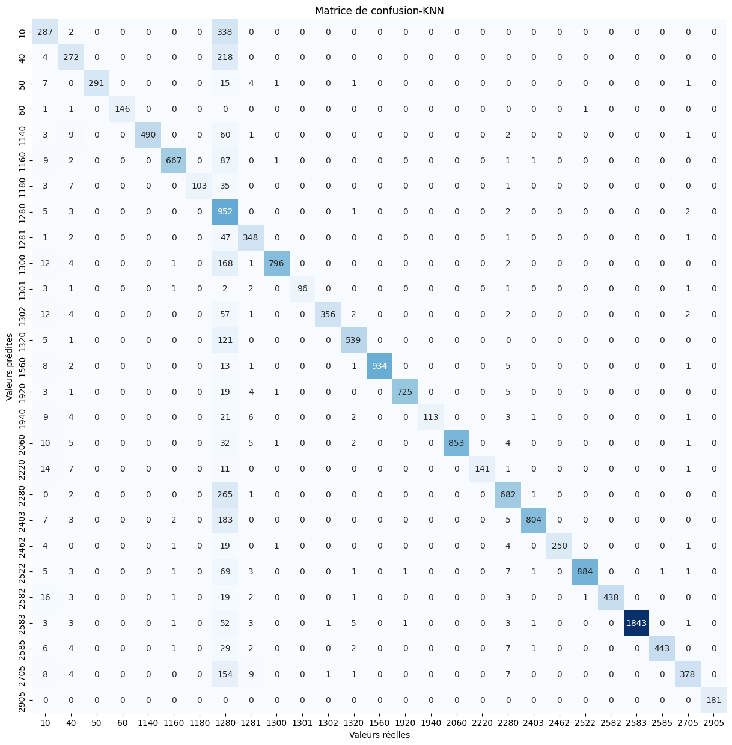

train_f1_score = [array([0.57901204, 0.68607825, 0.95127796, 0.98703404, 0.93035079,

0.93022476, 0.87568556, 0.48681333, 0.88793103, 0.90987821,

0.93099671, 0.92581944, 0.88107058, 0.98251479, 0.98434668,

0.89974293, 0.97252903, 0.94146744, 0.816935 , 0.87853233,

0.95158287, 0.95363889, 0.95509992, 0.98576165, 0.95005429,

0.82464956, 0.99855072])]

test_f1_score = [array([0.53544776, 0.64531435, 0.95253682, 0.98983051, 0.9280303 ,

0.92382271, 0.81746032, 0.48190332, 0.8776797 , 0.89187675,

0.94581281, 0.89672544, 0.88071895, 0.98367562, 0.97643098,

0.82783883, 0.96602492, 0.89240506, 0.80282519, 0.88643881,

0.94339623, 0.94900698, 0.95010846, 0.98031915, 0.94355698,

0.79162304, 1. ])]

train_mse_result = 160215.49750805323

test_mse_result = 184986.59539293745

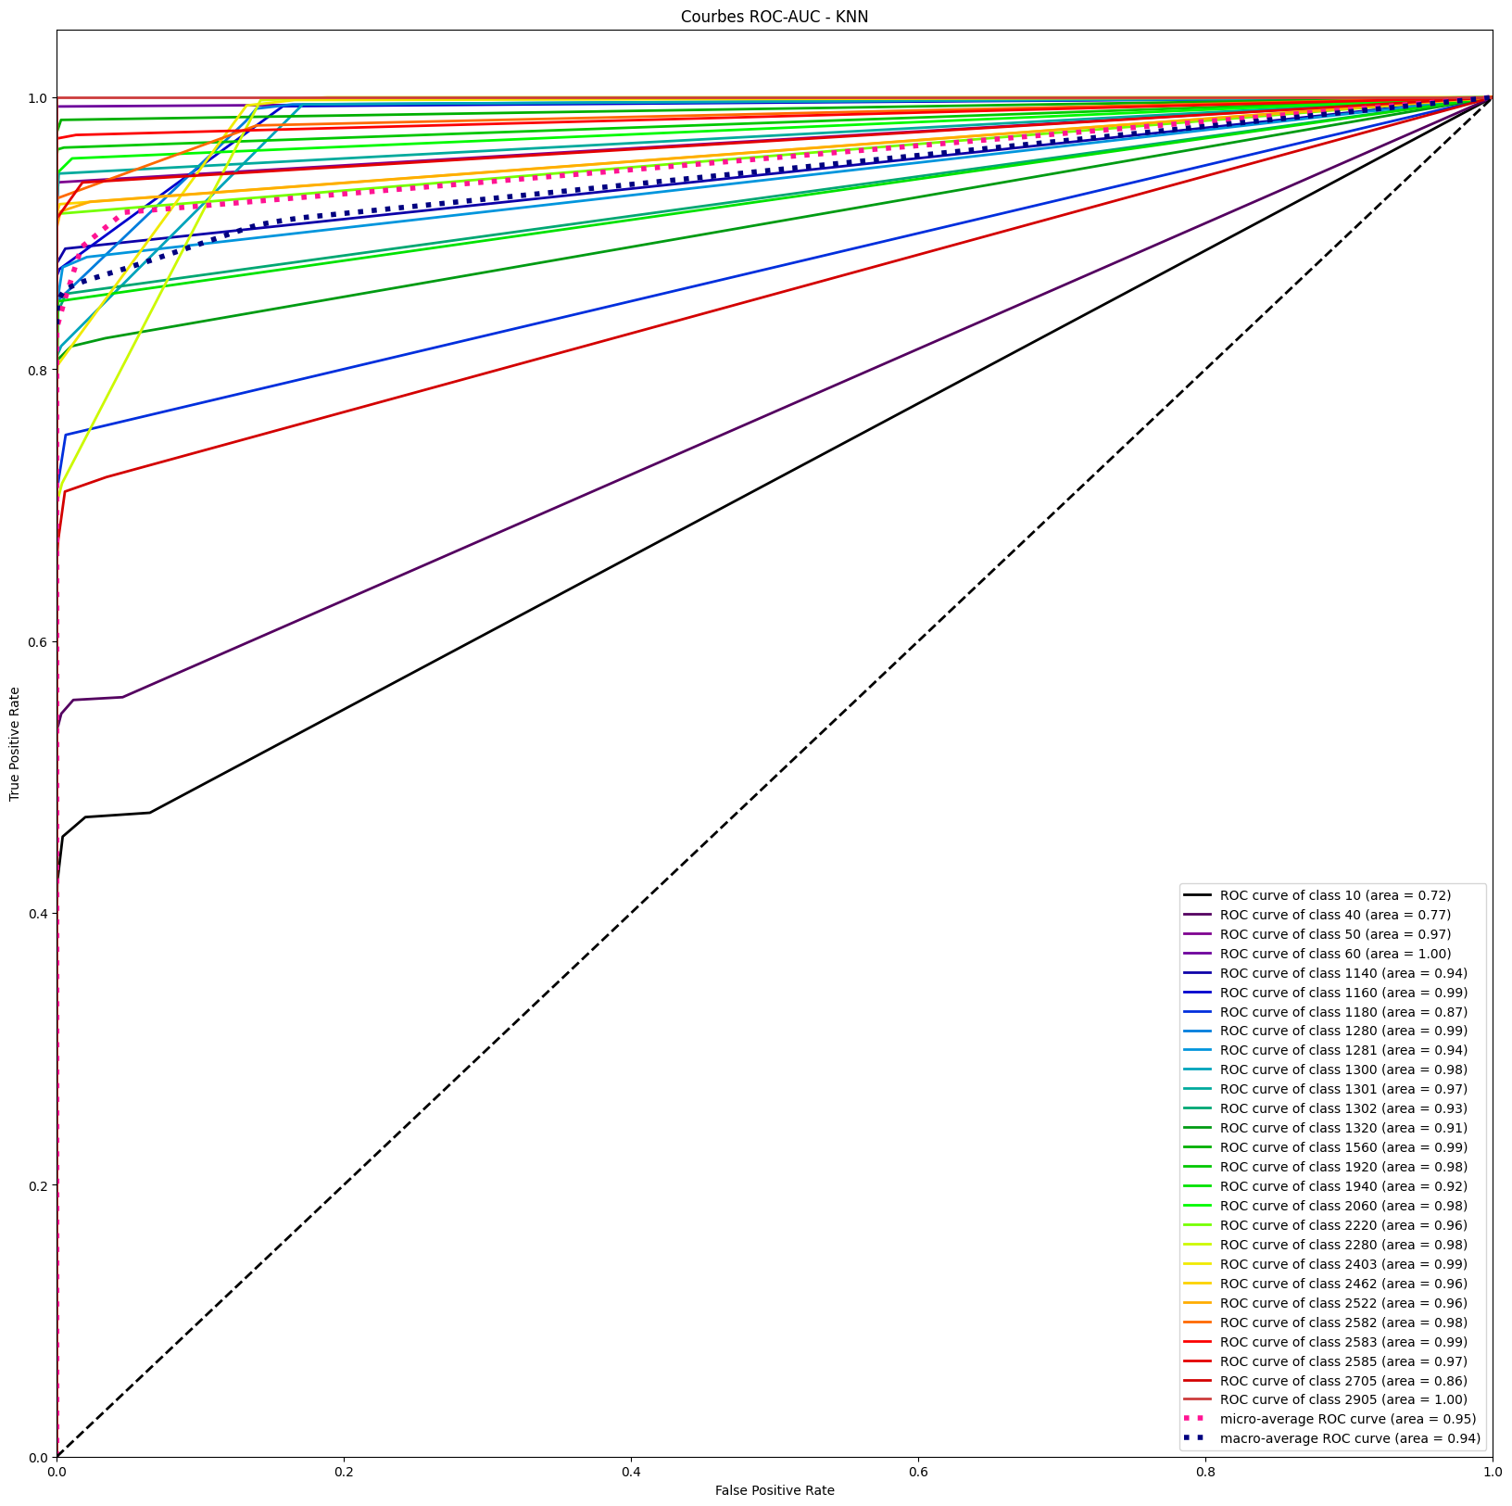

# KNN (150 words by code)

## estimator KNeighborsClassifier()

## params {'n_neighbors': [10]}

## train_r2_score = 0.8857199294961405

## test_r2_score = 0.8786847383455905

-----------------------------------------------------------------------

X_train.shape - X_test.shape - len(y_train) - len(y_test)

(65812, 4050) - (16453, 4050) - 65812 - 16453

Fitting 3 folds for each of 1 candidates, totalling 3 fits

============================CONFUSION MATRIX=======================================

3. Use SEABORN to draw confusion_matrix--------------------------------------------------------------

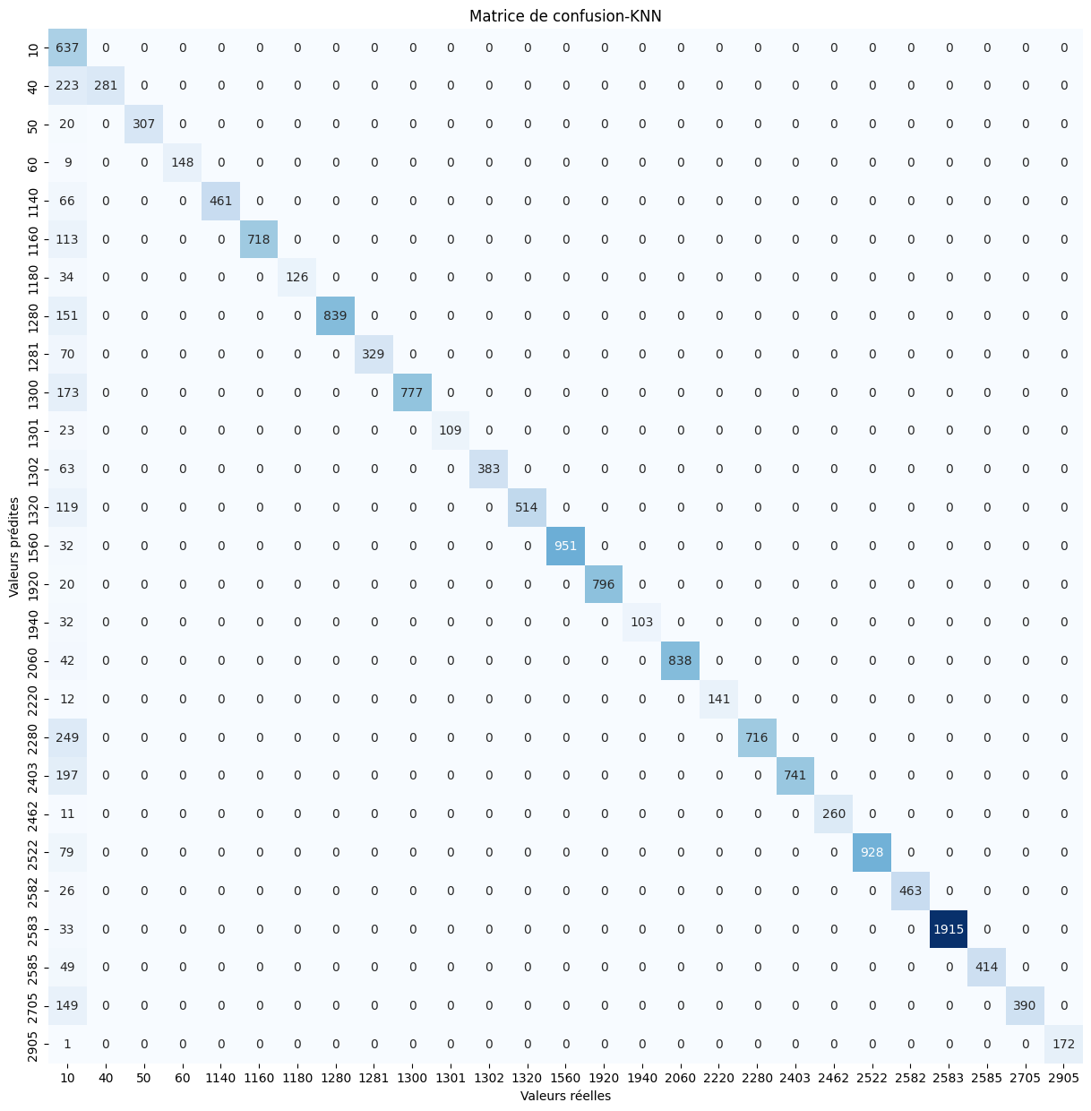

train_f1_score = [array([0.39711423, 0.72972973, 0.96431404, 0.99018003, 0.94329389,

0.93843537, 0.87940631, 0.9235361 , 0.92734032, 0.91129685,

0.94292237, 0.92778741, 0.89739729, 0.99012947, 0.98742666,

0.92679002, 0.9777964 , 0.95019763, 0.83607313, 0.89386929,

0.97977528, 0.96024384, 0.97210136, 0.98762054, 0.96360759,

0.83718487, 0.99928418])]

test_f1_score = [array([0.38960245, 0.71592357, 0.96845426, 0.9704918 , 0.93319838,

0.92704971, 0.88111888, 0.91744122, 0.90384615, 0.89982629,

0.90456432, 0.92400483, 0.89625109, 0.98345398, 0.98759305,

0.86554622, 0.97555297, 0.95918367, 0.85187388, 0.88266825,

0.97928437, 0.95917313, 0.97268908, 0.99145742, 0.94412771,

0.83961249, 0.99710145])]

train_mse_result = 389357.61490305717

test_mse_result = 398629.87017565186

best_params: [{'n_neighbors': 10}]

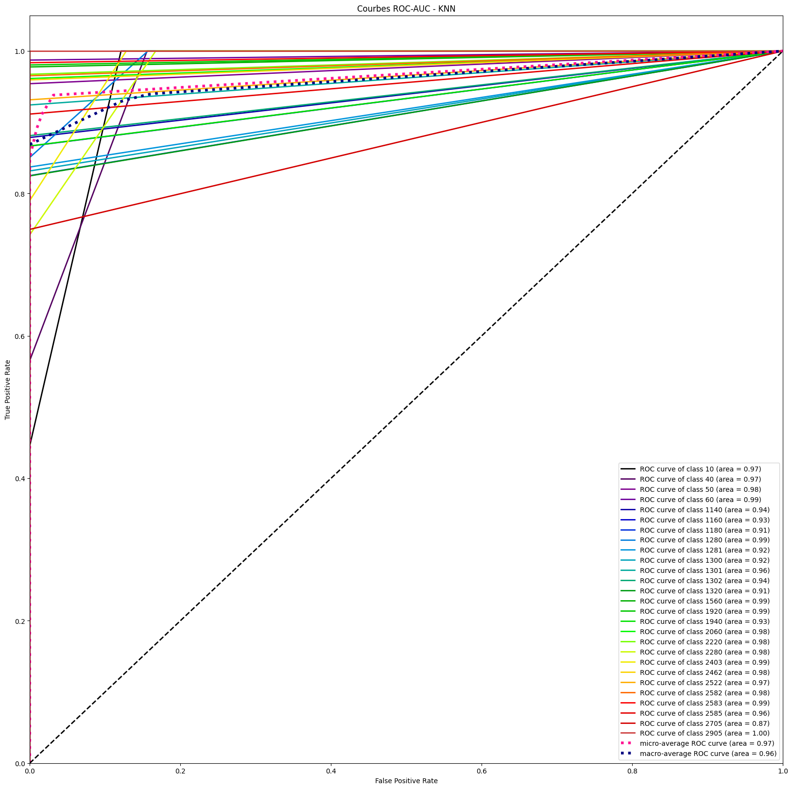

-----------------------------------------------------------------------

# KNN (150 words code) avec scaling

## estimator KNeighborsClassifier()

## params {'n_neighbors': [10, 12, 30]}

## **train_r2_score = 0.8887436941591199**

## **test_r2_score = 0.88160213942746**

-----------------------------------------------------------------------

df.shape : (82265, 4052)

Fitting 3 folds for each of 3 candidates, totalling 9 fits

X_train.shape - X_test.shape - len(y_train) - len(y_test)

(65812, 4050) - (16453, 4050) - 65812 - 16453

============================CONFUSION MATRIX=======================================

Use SEABORN to draw confusion_matrix-----------------------------------------------

Confusion matrix as graph with Seaborn :

train_f1_score = [array([0.41769083, 0.73500967, 0.9689298 , 0.99673736, 0.9419387 ,

0.93805907, 0.90718039, 0.92072124, 0.92792491, 0.91580663,

0.95499451, 0.93367639, 0.83938852, 0.98852649, 0.9897277 ,

0.92972058, 0.97787735, 0.9542903 , 0.83787973, 0.89236564,

0.98163905, 0.95949739, 0.97016461, 0.98893276, 0.96046697,

0.85121825, 0.99854227])]

test_f1_score = [array([0.39974043, 0.72592593, 0.97153025, 0.98726115, 0.94706449,

0.93103448, 0.84297521, 0.92807672, 0.92200557, 0.9048928 ,

0.9375 , 0.93544458, 0.83146067, 0.98527171, 0.98066298,

0.8590604 , 0.9728794 , 0.96226415, 0.8453134 , 0.88757396,

0.97328244, 0.96407186, 0.96335079, 0.98697847, 0.950783 ,

0.85623003, 1. ])]

train_mse_result = 361571.8485230657

test_mse_result = 382027.62973317935

**best_params: [{'n_neighbors': 10}]**

# KNN (100 words by code)

## train_r2_score = 0.8861802979450039

## test_r2_score = 0.8843028732925106

## best_params: [{'algorithm': 'auto', 'n_jobs': -1, 'n_neighbors': 10, 'weights': 'distance'}]

X_train.shape - X_test.shape - len(y_train) - len(y_test)

(67932, 2700) - (16984, 2700) - 67932 - 16984

estimator KNeighborsClassifier()

params {'n_neighbors': [10], 'weights': ['uniform', '...

-----------------------------------------------------------------------

Fitting 3 folds for each of 2 candidates, totalling 6 fits

train_f1_score = [array([0.39089334, 0.76324655, 0.95494071, 0.99925981, 0.92794814,

0.93105779, 0.8762421 , 0.90616622, 0.91707317, 0.91470786,

0.95813953, 0.94 , 0.90372272, 0.98390572, 0.98402839,

0.95230126, 0.97602475, 0.97179694, 0.81697044, 0.91878173,

0.97751799, 0.95299539, 0.98472906, 0.98477977, 0.959442 ,

0.85405961, 1. ])]

test_f1_score = [array([0.39637953, 0.73316062, 0.94256259, 0.99678457, 0.93346981,

0.94455578, 0.92830189, 0.9010503 , 0.87483871, 0.92225201,

0.9453125 , 0.9376392 , 0.90306947, 0.98521698, 0.96850862,

0.94642857, 0.98052921, 0.93103448, 0.81997372, 0.92016083,

0.97472924, 0.94807892, 0.97773475, 0.98227216, 0.9600863 ,

0.8380744 , 0.996997 ])]

train_mse_result = 382045.8192162751

test_mse_result = 388084.74004945834

============================CONFUSION MATRIX=======================================

Use SEABORN to draw confusion_matrix-----------------------------------------------

Confusion matrix as graph with Seaborn :

# KNN (100 words by code) après une **PCA** (réduction de 80% des variables) – 2min

## train_r2_score = 0.8463046252962986

## test_r2_score = 0.8340120342794627

## train_mse_result = 409521.15333069954

## test_mse_result = 195946.71190664318

## best_params: [{'n_neighbors': 10}]

Un minimum de **550** pour le # de composantes après réduction de dimensions PCA donnant un pourcentage de réduction de : **80.0 %**

df.shape : (82265, 2702)

X_train.shape - X_test.shape - len(y_train) - len(y_test)

(65812, 550) - (16453, 550) - 65812 – 16453

{'mean_fit_time': array([0.18550777]),

'std_fit_time': array([0.00195567]),

'mean_score_time': array([30.12307461]),

'std_score_time': array([0.06649759]),

'param_n_neighbors': masked_array(data=[10],

mask=[False],

fill_value='?',

dtype=object),

'params': [{'n_neighbors': 10}],

'split0_test_score': array([0.84086972]),

'split1_test_score': array([0.84159183]),

'split2_test_score': array([0.83753476]),

'mean_test_score': array([0.83999877]),

'std_test_score': array([0.00176708]),

'rank_test_score': array([1])}

# RFC - RandomForestClassifier (300 words by code) – the best

## train_r2_score = 0.9220203002491947

## test_r2_score = 0.9121740715978849

## best_params: [{'max_features': 'sqrt', 'min_samples_split': 10}]

X_train.shape - X_test.shape - len(y_train) - len(y_test)

(65812, 8100) - (16453, 8100) - 65812 - 16453

estimator RandomForestClassifier()

params {'max_features': ['sqrt'], 'min_samples_split'...

Fitting 3 folds for each of 1 candidates, totalling 3 fits

train_f1_score = [array([0.49328594, 0.79447115, 0.98415153, 0.99516908, 0.96825397,

0.95305318, 0.92307692, 0.94928335, 0.95154472, 0.92915893,

0.9894958 , 0.95852018, 0.93389297, 0.99550302, 0.99721813,

0.98020586, 0.98858892, 0.98505114, 0.89335485, 0.9163918 ,

0.98128708, 0.97629708, 0.99320071, 0.99503514, 0.97842105,

0.87859506, 1. ])]

test_f1_score = [array([0.46021666, 0.76601307, 0.97592295, 1. , 0.95626243,

0.93954135, 0.9122807 , 0.94246575, 0.94200849, 0.9255079 ,

0.97297297, 0.94911243, 0.92193919, 0.99454094, 0.99413681,

0.95709571, 0.98487395, 0.97313433, 0.90145577, 0.91160221,

0.95683453, 0.97393015, 0.98263534, 0.99424987, 0.97473684,

0.86831276, 1. ])]

mean_train_f1_score= 0.9400928726242548

mean_test_f1_score= 0.9308067817223938

**precision recall f1-score support**

10 0.30 1.00 0.46 616

40 1.00 0.62 0.77 472

50 1.00 0.95 0.98 319

60 1.00 1.00 1.00 150

1140 1.00 0.92 0.96 525

1160 1.00 0.89 0.94 763

1180 1.00 0.84 0.91 155

1280 1.00 0.89 0.94 965

1281 1.00 0.89 0.94 374

1300 1.00 0.86 0.93 952

1301 1.00 0.95 0.97 114

1302 1.00 0.90 0.95 444

1320 1.00 0.86 0.92 656

1560 1.00 0.99 0.99 1013

1920 1.00 0.99 0.99 772

1940 1.00 0.92 0.96 158

2060 1.00 0.97 0.98 906

2220 1.00 0.95 0.97 172

2280 1.00 0.82 0.90 981

2403 1.00 0.84 0.91 985

2462 1.00 0.92 0.96 290

2522 1.00 0.95 0.97 1043

2582 1.00 0.97 0.98 498

============================CONFUSION MATRIX=======================================

# LREG (100 words by code) – 4min

## best_params: [{'C': 30}]

## train_r2_score = 0.8658603294232055

## test_r2_score = 0.8622135780708685

X_train.shape - X_test.shape - len(y_train) - len(y_test)

(65812, 2700) - (16453, 2700) - 65812 - 16453

estimator LogisticRegression()

params {'C': [5, 10, 20]}

train_f1_score = [array([0.36140046, 0.66355763, 0.94627105, 0.99273608, 0.93363162,

0.9073154 , 0.89071038, 0.9119452 , 0.91848373, 0.90918919,

0.9622438 , 0.92756133, 0.87660327, 0.98651802, 0.98189068,

0.95114007, 0.97431555, 0.96634615, 0.79063803, 0.85167173,

0.96040987, 0.93652531, 0.98114169, 0.98680361, 0.96119882,

0.83593131, 1. ])]

test_f1_score = [array([0.35135908, 0.66854725, 0.94719472, 0.99665552, 0.92307692,

0.90294752, 0.89285714, 0.90837104, 0.92063492, 0.91075515,

0.94444444, 0.92493947, 0.85813751, 0.98750625, 0.97203728,

0.95016611, 0.97103918, 0.97005988, 0.7997558 , 0.85863268,

0.94927536, 0.93408278, 0.97636177, 0.98254892, 0.96162047,

0.83966245, 1. ])]

train_mse_result = 456855.5308302437

# RBF (100 words by code)

## train_r2_score = 0.8660274721935209

## test_r2_score = 0.8619704613140461

## best_params: [{'max_features': 'sqrt', 'min_samples_split': 10}]

X_train.shape - X_test.shape - len(y_train) - len(y_test)

(65812, 2700) - (16453, 2700) - 65812 - 16453

estimator RandomForestClassifier()

params {'name': 'RBF', 'estimator': ensemble.RandomForestClassifier(), 'params': {'max_features': ["sqrt", None],

                                                    'min_samples_split': [1, 10]}

                                         },

                                        {'name': 'SVC', 'estimator': svm.SVC(),

                                         'params': {'kernel':('linear', 'rbf'), 'C':[1, 10]}

                                         }

train_f1_score = [array([0.36168826, 0.66088117, 0.94627105, 0.99273608, 0.93363162,

0.9073154 , 0.89071038, 0.9119452 , 0.91848373, 0.90918919,

0.9622438 , 0.92756133, 0.87660327, 0.98651802, 0.98189068,

0.94857143, 0.97431555, 0.96634615, 0.79063803, 0.85341426,

0.96040987, 0.93725222, 0.98140127, 0.98680361, 0.96203209,

0.83623877, 1. ])]

test_f1_score = [array([0.35169854, 0.66288952, 0.94719472, 1. , 0.92307692,

0.90373563, 0.89285714, 0.90775325, 0.91907514, 0.90700344,

0.93457944, 0.92493947, 0.85813751, 0.98801199, 0.97272122,

0.93602694, 0.97103918, 0.96072508, 0.8014661 , 0.86192952,

0.95306859, 0.93408278, 0.97636177, 0.98281787, 0.95940171,

0.84332282, 1. ])]

train_mse_result = 455162.75148909015

test_mse_result = 475895.7078344375

# NAIVE BAYES (100 words by code) – 11sec temps d’excucution

## params {'alpha': [1]}

## train_r2_score = 0.8464261836747098

## test_r2_score = 0.8450738467148848

## mean_train_f1_score= 0.8964021730543796

## mean_test_f1_score= 0.895199049313926

X_train.shape - X_test.shape - len(y_train) - len(y_test)

(65812, 2700) - (16453, 2700) - 65812 - 16453

# RF (100 words by code):

## Fitting 3 folds for each of 1 candidates, totalling 3 fits

## train_r2_score = 0.8693095484106242

## test_r2_score = 0.8640977329362426

train_mse_result = 446904.01537713484

test_mse_result = 465541.4230231569

best_params: [{'max_features': 'sqrt', 'min_samples_split': 100}]

============================CONFUSION MATRIX=======================================

3. Use SEABORN to draw confusion_matrix--------------------------------------------------------------

Confusion matrix as graph with Seaborn :

# SVC (100 words by code)

## train_r2_score = 0.8660274721935209

## test_r2_score = 0.8574120221236249

## best_params: [{'C': 10, 'kernel': 'linear'}]

params {'kernel': ('linear', 'rbf'), 'C': [10, 20]}

X_train.shape - X_test.shape - len(y_train) - len(y_test)

(65812, 2700) - (16453, 2700) - 65812 - 16453

train_f1_score = [array([0.36168826, 0.66088117, 0.94627105, 0.99273608, 0.93363162,

0.9073154 , 0.89071038, 0.9119452 , 0.91848373, 0.90918919,

0.9622438 , 0.92756133, 0.87660327, 0.98651802, 0.98189068,

0.94857143, 0.97431555, 0.96634615, 0.79063803, 0.85341426,

0.96040987, 0.93725222, 0.98140127, 0.98680361, 0.96203209,

0.83623877, 1. ])]

test_f1_score = [array([0.34432644, 0.66099291, 0.94719472, 0.99328859, 0.91975309,

0.90215827, 0.88489209, 0.9052751 , 0.91751085, 0.90574713,

0.90909091, 0.92363636, 0.85614647, 0.98293173, 0.96722408,

0.93243243, 0.96928328, 0.94478528, 0.8007335 , 0.86192952,

0.94545455, 0.93244626, 0.97425335, 0.98201058, 0.95605573,

0.83474576, 1. ])]

train_mse_result = 455162.75148909015

test_mse_result = 492912.0065641524

# KNN (300 word by code)

## train_r2_score = 0.9067799185558865

## test_r2_score = 0.9002613505135841

## estimator KNeighborsClassifier()

## params {'n_neighbors': [10]}

X_train.shape - X_test.shape - len(y_train) - len(y_test)

**(65812, 8100) - (16453, 8100) - 65812 - 16453**

Fitting 3 folds for each of 1 candidates, totalling 3 fits

train_f1_score = [array([0.75349301, 0.8144208 , 0.9837587 , 0.98947368, 0.42818645,

0.96005218, 0.90762332, 0.94754279, 0.95120364, 0.92673847,

0.97002141, 0.95146727, 0.93545683, 0.99200619, 0.99376026,

0.94339623, 0.98420685, 0.964687 , 0.89900759, 0.92226501,

0.98637602, 0.97737438, 0.98398983, 0.99484071, 0.96810207,

0.799908 , 0.97447119])]

test_f1_score = [array([0.74541752, 0.8035488 , 0.98245614, 0.97260274, 0.41079812,

0.9569378 , 0.90070922, 0.94072448, 0.95384615, 0.9218573 ,

0.95412844, 0.94033413, 0.92193919, 0.98801199, 0.99282453,

0.88732394, 0.97972973, 0.94153846, 0.91482301, 0.92876563,

0.97707231, 0.97795198, 0.96465696, 0.99503787, 0.96051227,

0.77019749, 0.95031056])]

**train_mse_result = 96349.62113292409**

**test_mse_result = 103203.23928766791**

**best_params: [{'n_neighbors': 10}]**

============================CONFUSION MATRIX=======================================

-----------------------------------------------------------------------

# NAIVE BAYES (300 words by code) – 30sec temps d’excucution

## estimator MultinomialNB()

## params {'alpha': [1]}

## train_r2_score = 0.9078283595696833

## test_r2_score = 0.9073117364614356

## mean_train_f1_score= 0.9392493667037067

## mean_test_f1_score= 0.9379498799117439

train_mse_result = 229948.6231842217

test_mse_result = 236261.5843919042

best_params: [{'alpha': 1}]

train_f1_score = [array([0.74661315, 0.79447115, 0.98415153, 0.99435939, 0.96825397,

0.95305318, 0.92307692, 0.94928335, 0.95154472, 0.92915893,

0.9894958 , 0.95852018, 0.93389297, 0.99550302, 0.99721813,

0.98020586, 0.98858892, 0.98505114, 0.89335485, 0.9162604 ,

0.98128708, 0.97629708, 0.99320071, 0.71987437, 0.97842105,

0.87859506, 1. ])]

test_f1_score = [array([0.72066459, 0.77561608, 0.98569157, 1. , 0.96653543,

0.95264242, 0.92733564, 0.94593119, 0.9596662 , 0.92853123,

0.97757848, 0.95652174, 0.92810458, 0.99503968, 0.9974026 ,

0.98717949, 0.98827471, 0.98823529, 0.90696379, 0.91826659,

0.97707231, 0.9784525 , 0.98883249, 0.71630678, 0.97796432,

0.87983707, 1. ])]

mean_train_f1_score= 0.9392493667037067

mean_test_f1_score= 0.9379498799117439

# LREG (300 words by code)

## estimator LogisticRegression()

## params {'C': [50]}

## train_r2_score = 0.8932109645657327

## test_r2_score = 0.8905974594298912

{'mean_fit_time': array([108.86818051]),

'std_fit_time': array([3.84594668]),

'mean_score_time': array([0.80805755]),

'std_score_time': array([0.09732477]),

'param_C': masked_array(data=[50],

mask=[False],

fill_value='?',

dtype=object),

'params': [{'C': 50}],

'split0_test_score': array([0.88809372]),

'split1_test_score': array([0.88872681]),

'split2_test_score': array([0.88412272]),

'mean_test_score': array([0.88698108]),

'std_test_score': array([0.00203763]),

'rank_test_score': array([1])}